1. **Starting the Game**:
   * The game will prompt the number of players and their names.
   * It initializes each player with a starting balance of $1500.

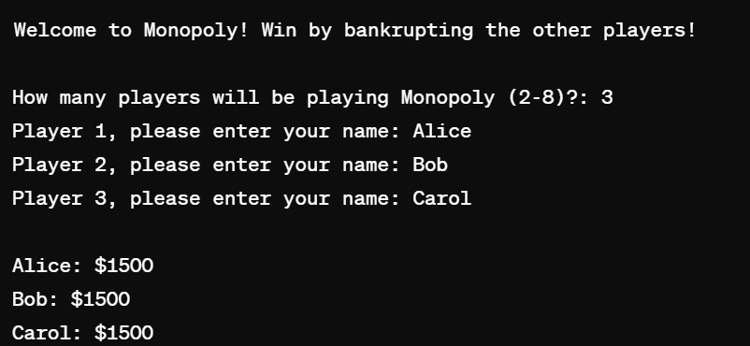

1. **Gameplay**:
   * Each player's turn involves rolling the dice, moving the specified number of spaces, and interacting with the space they land on.
   * Players may purchase properties or draw cards from the Community Chest.

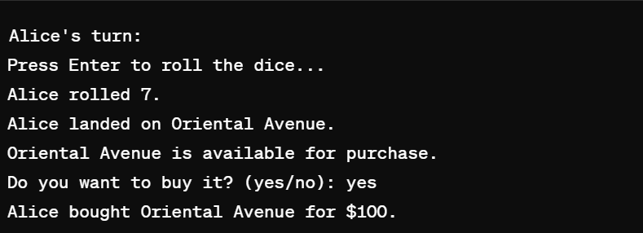

1. **Continued Turns**:
   * Players continue taking turns, rolling dice, and making decisions on properties or reacting to the spaces they land on.
   * Rent payments, tax payments, and other financial transactions occur based on board space rules.

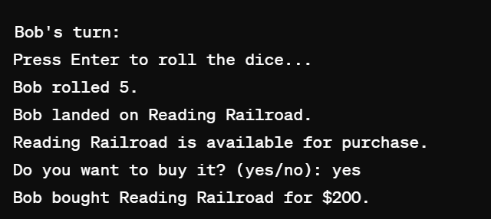

1. **End-Game Scenarios**:
   * The game checks for bankruptcy. If a player cannot pay what they owe, they are declared bankrupt.
   * The game concludes when only one player remains who isn't bankrupt or after a set number of rounds.

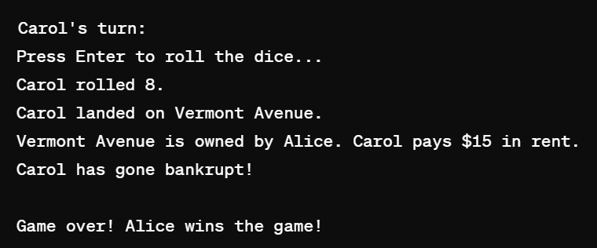

1. **Game Over**:
   * The game prints a message indicating who the winner is or if it's a draw after the maximum rounds.